The City at Eye Level ASIA
Lessons and strategies for a great city at eye level in Asian cities
Open Call for Contributions - Submit your Chapter Proposal!

We are really proud of the collective work from so many partners that led to the previous editions of The City at Eye Level books. We have and still do receive many great reactions from all over the world.

In early 2012, STIPO started the project that would become The City at Eye Level: Lessons for Street Plinths, a book that was published by the end of that year. We sought collective answers to the question: How can we create a user-friendly ground-level that is flexible for years to come, adaptive for multiple uses, pleasing to the eye, and all with little financial resources? The project rapidly developed into an open source project with more than 40 contributing co-authors from its network in not just the Netherlands, but also from Europe and America. But the story continues. Ever since 2016 The City at Eye Level is growing internationally with new editions such as "A Cidade ao Nivel dos Olhos" for the Brazilian market, "The City at Eye Level in The Netherlands" and "The City at Eye Level for Kids". Next step: "The City at Eye Level Asia-Pacific!"

We look for successful and inspiring examples in Asia-Pacific cities of qualitatively strong and pleasant public spaces, streets, plazas and buildings. Therefore, we have invited new chapters, presenting either a framework or approach and/or a case study from your experience. The collection of new chapters and stories will be shared through our online platform, The City at Eye Level. The book will work towards the Placemaker Week in Malaysia in 2019 with the launch of the book and Asian Placemaking Network. The predetermined and selected ambassadors will together form the full program and speakers list of the Placemaking Week in Malaysia with the book launch, plenary sessions, workshops and break-out sessions as well as field trips to case studies from the book and Asian versions of plinth- and place games.

Content related considerations
Responding to the challenges the following themes are selected as framework for the book and curation of proper cases as content:
FLUID X FORMAL  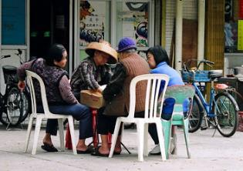 | Resident-created or upgraded public spaces - How to amplify to resident created public spaces? We look at citizen-led examples of urban upgradings, like random street corners or bus stops turned into lovely sitting out areas or community gardens with home-made furniture, pots and plants, religious artefacts and even self-fabricated exercise equipment. | PRAY X PLAY  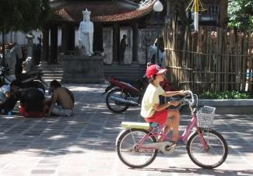 | Religious sites as public spaces - How to replicate the shared space concept of urban religious sites? We look at temple complexes, churchyards, mosque compounds and school grounds that also function as important public, community and recreational spaces, not just to pray but also to play.
DAY X NIGHT  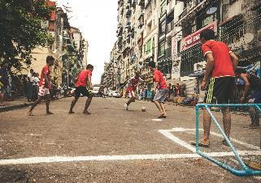 | Multi-purpose day/night spaces - How to optimise use of space in cities that are dictated by hot climate and high rents? We look at creative use and management of spaces; for example a street food market in the morning, traffic lane during the day and a football pitch by night, or busy thoroughfare during the week and pedestrian zone in the weekend. | PUBLIC X PRIVATE  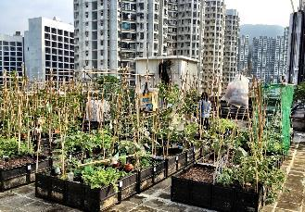 | Privately managed public spaces - How to demarcate the line In between what is public and private space in a dense urban environment? It is often blurred. We look at successful examples of privately managed public spaces that are responding to the citizens needs such as rooftops, arcades, footbridges.
COLOUR X CREATIVITY  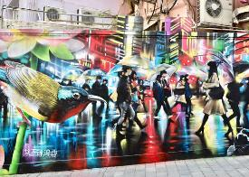 | The city as a canvas for urban creatives - How to use streets and back alleys as performance venues, exhibition space and creative outlet for urban artists and performers? We look at successful artistic projects that do good for the city and community. | OLD X NEW  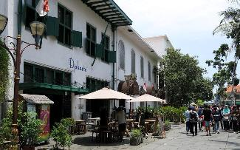 | Keeping the human scale in skyscraper cities -How to use the qualities of old city centres (human scale, character, open squares, walkable streets) and translate them successfully for high rise environments? How to keep activity at street level?
INDOOR X OUTDOOR  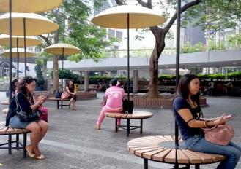 | Creating a comfortable environment - How to create comfortable spaces when the urban environment becomes hostile for humans? How to deal with heat, pollution and flooding? We look at creative solutions like providing shaded streets, connecting walkways, water gardens and separated cycling lanes. | OVERCROWDING X UNDERUSED  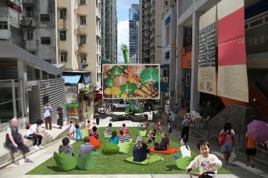 | Accessibility and empty spaces - How to steer people away from overcrowded places and open up underused spaces? Parks, plazas, waterfronts are not always accessible for all. We look at places where attractive spaces were created in unusual places like under footbridges, disused laneways or overpasses.

Our editorial team approaches the themes from three perspectives and three levels central to The City at Eye Level. The perspectives are: the software, the hardware and the orgware of a public realm; respectively reflecting the use, the design and the organisation of the public realm. Furthermore, three levels in the city scape are: the level of the building, the street and the context. Our invitation is open to chapters and case studies that reflect either, both or all three perspectives and levels.

You can read more about the City at Eye Level approach by downloading the book for free from here: https://thecityateyelevel.com/share-knowledge/get-the-book/

CONTACT INFORMATION
Siënna Veelders // sienna.veelders@stipo.nl
Husain Al-Afoo // husain.al-afoo@stipo.nl
Hans Karssenberg // hans.karssenberg@stipo.nl

The City at Eye Level for Kids - Submit your Chapter Proposal!
You may either submit your chapter proposal by filling out a quick and easy google form, or just email us a document with the requested fields (read below).

The submitted proposals will be reviewed by the editorial team of The City at Eye Level Asia, following a point grading system. A member of our team will contact you in order to inform you on the acceptance of your proposal, and whether there is any feedback to be taken into consideration.
If your proposal gets accepted, we will provide you with further information on the guidelines for the full chapter.

Please, fill in the following Google Form: https://forms.gle/RR5SHjZxrqc98Jjy9
OR

Please, send us a document with the following contents to this email: husain.al-afoo@stipo.nl

- Title of the proposed chapter (if it is a case-study, please include the title of the project and the city)
- Name and job description of the contributor
- Context: a short introduction to the framework or approach and/or a case study (300 words)
- A three-line biography of the contributor
The deadline for submitting your proposal is on the 24st of June 2019.

Full Chapter Contribution - Guidelines
CONTENT RELATED CONSIDERATIONS
The project is:
- situated in an Asian city
- tapping into one or more themes in the book (as mentioned above)
- an innovative solution, against the current of traditional solutions in urban planning)
- has had an impact/change on one of the themes
- initiated from
  - bottom-up (community based/civic)
  - middle-up-town-down (private organisation connecting top and bottom
  - top-down (preferably as a participative process, together with the community)
- able to provide a peek behind the scenes. This requires openness about backstage processes like not only success but also struggles, solutions, process and cash flows.
- a finished project, but when still ongoing project its a must to have some achieved milestones.

GUIDELINES FOR WRITING YOUR OWN ARTICLE
- 800 words in English (to be discussed otherwise)
- Consider the following structure:
  - First section: Introduction to your cases and used concepts
  - Middle section: Description of your case and analysis
  - Final section: Conclusions, lessons learned and practical implications
  - Concluding conclusions and lessons, informative for other practitioners in Asia-Pacific cities
- High resolution pictures, free of rights, to help strengthen the article. Preferable from before, during project and from the end result.
- All contributions are subject to editing.

FULL CHAPTER SUBMISSION DEADLINE
The deadline for submitting your final full chapter is on the 26th of August 2019.

The City at Eye Level in Asia is a collaboration between:
